RESUME
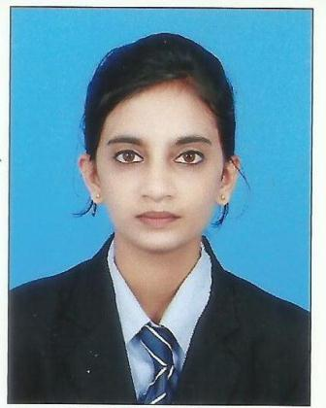
SUNAIDA M A
D/O ABDULLA M A
KANTHUR VILLAGE & MURNAD POST
MADIKERI TALUK-571252
CONTACT NO:9008927395
EMAIL.ID:Sunaidasunii7@gmail.com
CAREER OBJECTIVE:
“To be a part of an organization where I can fully utilize my skills and make a significant contribution to the success of the employer and at the same time my individual growth.”
Academic Qualification:
QUALIFICATION | INSTITUTION | UNIVERSITY/  BOARD | YEAR OF PASSING | PERCENTAGE
B.COM | FIRST GRADE COLLEGE MURNAD | MANGALORE | 2019 | 72%
2ND PUC | MURNAD PU COLLEGE | PU BOARD | 2016 | 70 %
S S L C | MURNAD HIGH SCHOOL | STATE BOARD | 2014 | 72%
Technical and Computer Proficiency:
BASIC KNOWLEDGE ABOUT MS OFFICE

Project and Training Camp Attended:
1. Attended two days leadership training camp organized by M.R Pai foundation & forum free enterprises, Bombay
2.Attended one day Business Communication Training camp.
3. Participated in creating awareness on Swachh Bharat under the college programe clean India Brigade.
4. Visited Infosys training campus, Mysore to Understand corporate culture.
Strengths:
Leadership quality,Grasping power,Team Worker,Self confident,Good Analiytical Skills.

Achievement:
I Participated in NSS camp.
Working Experience:
6 Month Experience in trident auto enter Pvt LTD as a sales consultant.

Personal profiles:
Date of Birth : 27/01/1999
Father Name : Abdulla M A
Gender :Female
Hobbies :Gardening, Listening music and Shuttle
Language Known : Kannada,English,and Malayalam
Declaration:
I here by declare that the information furnished above is true to the best of my knowledge.
Place: MURNAD SUNAIDA M A
Date:

